UNSUPERVISED LEARNING AND CREDIT RATING: A CLUSTERING STUDY OF VIETNAM
Tam Phan Huy ^{1*}, Vi Lam Thanh ¹, Linh Duong Thi Thuy ¹, Oanh Tran Thi Kieu ¹, Huyen Nguyen Thi Ngoc ¹, Hanh Nguyen Thi Duc Hanh ¹
¹ University of Economics and Law, Ho Chi Minh City, Vietnam and Vietnam National University, Ho Chi Minh City, Vietnam.
*Corresponding author: tamph@uel.edu.vn

ABSTRACT
This study develops a transparent, theory-informed segmentation of Vietnamese listed firms for credit-rating purposes by applying K means clustering to a multi-dimensional set of fundamentals, valuation, capital structure, ownership, and location variables. The dataset comprises 3,528 firm-year observations for 692 firms on the Ho Chi Minh Stock Exchange and the Hanoi Stock Exchange during 2019 to 2024, drawn from Refinitiv. The data are cleaned by removing missing and inconsistent records and filtering extreme observations using a Z-score rule before standardizing continuous features. The number of clusters is chosen using internal validation criteria, including the silhouette coefficient, the Calinski–Harabasz index, and the Davies–Bouldin index, yielding a four-cluster solution that balances compactness and separation and remains stable across random initializations. The largest cluster combines lower leverage, higher foreign ownership, and stronger valuation signals; a second cluster is more debt dependent; a third displays tight short-term liquidity; and a small residual cluster exhibits very high profitability with very low leverage. Principal component analysis confirms visual separation, and cross-tabulations by sector and region show that the structure is not driven by a single industry or location. The results provide an interpretable, reproducible map of firm heterogeneity that can support screening, monitoring, and pricing decisions in a credit-rating orientation.
Keywords: Credit rating segmentation; Unsupervised clustering; Machine learning; Vietnam.

1. INTRODUCTION
Efficient resource allocation in Vietnam’s equity market is hindered by heterogeneous firm fundamentals, information frictions, and liquidity conditions that make it difficult to see how risk and performance drivers combine across firms. Classical asset-pricing theories imply that expected returns covary with systematic risk and firm characteristics, yet these relations may look different in an emerging market setting and are not easily translated into transparent firm groupings for risk screening (Ross, 2013; Sharpe, 1964). Vietnam-specific evidence further shows that factor payoffs and sentiment differ from developed markets, reinforcing the need for a market-wide segmentation grounded in both theory and local data (Phong & Hoang, 2012; Thanh et al., 2024).
The current literature provides strong hints about which variables matter. Studies link liquidity and ownership structure to returns and trading frictions in Vietnam, especially around stress periods, while work on intellectual capital and governance ties intangible resources to performance (Nguyen et al., 2021; Nguyen, 2024; Tran et al., 2018; Tran et al., 2022). In parallel, research on credit risk and corporate failure shows that modern algorithms can outperform linear baselines, and recent Vietnamese applications demonstrate the feasibility of using clustering or neural networks for rating-oriented tasks (Pham et al., 2022; Tam & Quang, 2024; Zięba et al., 2016). What is still limited is an unsupervised, theory-informed segmentation of listed firms in Vietnam that can be interpreted in a credit-rating orientation.
The significance of this study is threefold. First, it translates well-known theories of capital structure, information and signaling, and credit risk into a coherent feature set for unsupervised learning, moving beyond ad hoc variable lists toward mechanism-anchored inputs. Second, it provides a market-wide clustering that reveals persistent cross-sectional structure in fundamentals, ownership, and geography, which can inform screening, monitoring, and policy. Third, it follows recent Vietnamese evidence on governance and intellectual capital to ensure that feature design reflects local drivers of performance as well as theory.
The single research objective is to discover economically interpretable clusters of Vietnamese listed firms during 2019–2024 using a theory-informed feature set and the K-means algorithm, and to interpret those clusters in a credit-rating orientation, building on recent local advances in factor modeling and rating applications. The remainder of the paper is organized as follows. Section 2 reviews background theories and synthesizes related empirical evidence with an emphasis on Vietnam. Section 3 describes the data, variable construction, and clustering methodology. Section 4 reports the clustering results and their economic interpretation, including cross-tabs by sector and region and principal-component diagnostics. Section 5 concludes and outlines recommendations and future research directions.

2. THE THEORETICAL AND EMPIRICAL REVIEW

2.1. Key Concepts
Foundational theories in finance provide an essential conceptual basis for understanding the variables that influence firm performance, risk, and return. Within the efficient market framework, expected returns are shaped by systematic risk, which highlights market beta, volatility, firm size, value, profitability, and investment as central constructs (Fama, 1970; Fama & French, 1993, 2015; Sharpe, 1964). Momentum effects further emphasize the informational content of past returns and trend signals (Jegadeesh & Titman, 1993). Liquidity, informational environments, leverage choices, and governance structures also contribute to firm-level differences and are therefore conceptually relevant to empirical modeling (Akerlof, 1978; Jensen, 1986; Modigliani & Miller, 1963; Myers & Majluf, 1984). Credit-risk and distress frameworks underscore the importance of profitability, leverage, liquidity, volatility, and valuation metrics in predicting default (Altman, 1968; Merton, 1974). Beyond traditional finance, resource-based perspectives highlight intangible resources, human capital, and organizational capabilities as determinants of long-term performance differentials (Barney, 1991). Collectively, these concepts justify the inclusion of a diverse set of market-based, accounting-based, structural, and capability-oriented variables in empirical research.

2.2. Theories of Research Issues
A broad set of financial theories provides the rationale for selecting variables that explain corporate outcomes. Asset pricing theories argue that systematic risks and firm characteristics influence expected returns, thereby motivating the use of beta, volatility, size, value, profitability, investment intensity, and momentum-related variables (Fama & French, 1993, 2015; Jegadeesh & Titman, 1993; Ross, 2013). Capital structure theories further emphasize trade-offs among tax benefits, bankruptcy costs, and financing frictions, supporting the use of leverage ratios, interest coverage, tax measures, internal cash flow, and ownership-related indicators (Kraus & Litzenberger, 1973; Modigliani & Miller, 1963; Myers, 1984). Information asymmetry and signaling theories stress the role of liquidity, trading frictions, disclosure quality, and costly signals such as leverage changes or dividend policies (Akerlof, 1978; Amihud, 2002; Ross, 1977). Distress and credit-risk models—from structural approaches to hazard frameworks—highlight the predictive relevance of profitability, liquidity, market valuation, volatility, and leverage (Jarrow & Turnbull, 1995; Merton, 1974). Complementing these views, resource-based theories propose that intangible assets and organizational capabilities generate sustained advantages, encouraging the incorporation of variables capturing human capital, innovation, and structural capital (Barney, 1991). These theoretical foundations collectively provide a coherent justification for constructing an economically grounded feature set for empirical and machine learning models.

2.3. Empirical Review
Empirical evidence from Vietnam and international markets reinforces the theoretical relevance of multiple firm characteristics, liquidity measures, and governance indicators. Studies on asset pricing in Vietnam consistently document that size, earnings yield, turnover, and profitability offer explanatory power beyond market beta, while local refinements of global models improve performance in the context of an emerging market (Huang et al., 2023; Phong & Hoang, 2012; Thanh et al., 2024). Liquidity research shows that trading activity and market tightness significantly affect returns, especially during the COVID-19 period, and that ownership composition—such as state, foreign, and institutional stakes—shapes liquidity conditions (Luong et al., 2022; Nguyen et al., 2021; Tran et al., 2018). Empirical work on intangible capital and governance demonstrates strong associations between intellectual capital components, governance quality, CSR initiatives, leverage interactions, and firm performance (Luu et al., 2024; Nguyen, 2024; Tran et al., 2022). In the field of financial distress prediction, machine learning models such as gradient boosting, survival forests, and neural networks outperform classical approaches, with profitability, leverage, cash flow indicators, volatility, and relative size emerging as key predictors (Alanis et al., 2022; Barboza et al., 2017; Zięba et al., 2016). For the banking sector, Vietnamese studies using data envelopment analysis and stochastic frontier analysis show that cost and technical efficiency vary with ownership structures, competition, scale, and macroeconomic shocks, implying that balance-sheet indicators, asset quality metrics, capital adequacy, and ownership variables are essential for empirical modeling (Anh et al., 2017; Pham et al., 2022; Tam & Quang, 2024). Overall, the empirical literature supports a comprehensive, context-specific set of variables aligned with theoretical expectations and suitable for advanced predictive modeling.

3. RESEARCH METHOD

3.1 Data
This study builds a panel of firm-year observations from Refinitiv’s secondary data for companies listed on the Ho Chi Minh Stock Exchange and the Hanoi Stock Exchange over the period 2019 to 2024. The dataset combines standard market information with annual accounting statements at the firm level. Sample construction follows transparent inclusion rules. We begin with all firms that appear in Refinitiv during 2019 to 2024 and that have both market and financial statement data for at least one year in this window. We exclude observations with missing or internally inconsistent fields required for modeling and remove duplicate entries after merging accounting and price files by firm and year. Monetary variables and ratios are kept exactly as reported by the source to avoid researcher-induced distortions at this stage. Categorical variables such as sector and exchange membership are carried from the source files without reclassification.
Data quality filtering proceeds in two steps. First, we drop observations with missing values in any of the variables used in the baseline models or diagnostics. Second, we remove extreme outliers using a standard Z-score rule applied to each continuous variable; observations with an absolute Z-score greater than a conventional threshold are treated as outliers and excluded from the analytic sample. This approach reduces the influence of data entry errors and extreme reporting realizations that would otherwise dominate estimation and prediction while maintaining a transparent and replicable screening rule grounded in standard statistical practice. After these screens, the final dataset contains 692 unique firms and 3,528 firm-year observations over 2019 to 2024.
Table 1: Variables measurement
Variables |  | Symbol | Measurement
Firm performance | Return on Asset | roa | Net Income / Total Asset
 | Return on Equity | roe | Net Income / Total Equity
 | Return on Sales | ros | Net Income / Total Sales
Stock market performance | Earnings per share | eps | Net Income / Outstanding
 | P/E ratio | historic pe | Price per share / Earning per share
 | M/B ratio | M_b | Market value / Book value
Leverage |  | lev | Total Debt / Total Asset
Net working capital |  | nwc | Net Working capital / Total Asset
Firm Size |  | size | ln(Total Asset)
Age |  | age | Firm Age
Foreign Ownership |  | Foreign ownership | Percentage of foreign ownership
Location Hanoi |  | location_HN | Dummy variable: 1 if headquarter located in Hanoi, 0 if otherwise
Location central |  | location_central | Dummy variable: 1 if headquarter located in central area, 0 if otherwise
Location others |  | location_other | Dummy variable: 1 if headquarter located in other region (not central or Hanoi), 0 if otherwise
(Source: by author)
Table 1 summarizes variable definitions used in the analysis. Firm performance is proxied by return on assets (roa = net income divided by total assets), return on equity (roe = net income divided by total equity), and return on sales (ros = net income divided by total sales). Stock market performance measures include earnings per share (eps = net income divided by shares outstanding), the price to earnings ratio (historic pe = price per share divided by earnings per share), and the market to book ratio (M_b = market value divided by book value). Capital structure is captured by leverage (lev = total debt divided by total assets), liquidity and working capital by net working capital scaled by total assets (nwc), firm scale by the natural logarithm of total assets (size = ln of total assets), and maturity by firm age in years (age). Ownership structure is represented by the percentage of foreign ownership. Geographic effects are controlled using three mutually exclusive location indicators: location_HN equals 1 if the head office is in Hanoi, location_central equals 1 if the head office is in a central region, and location_other equals 1 if the head office is in a region that is not central or Hanoi; each indicator equals 0 otherwise.

3.2 Models
This study applies K means clustering to group firms with similar multi dimensional financial and market profiles. The unit of analysis is the firm. For each firm, a feature vector is constructed from the variables in. To emphasize persistent characteristics rather than temporary spikes, each continuous variable is aggregated at the firm level over 2019 to 2024 using the time average. Location enters as three mutually exclusive indicators for Hanoi, central, and other. This design allows the algorithm to discover clusters that combine fundamentals with ownership and geography without imposing any linear structure.
K means partitions the set of firms into K clusters by minimizing the within cluster sum of squared Euclidean distances to cluster centroids. The procedure uses k means plus plus initialization to improve the quality of starting centroids and to reduce sensitivity to local minima, and it is executed with multiple random starts under a fixed seed for reproducibility. The algorithm iterates between assigning firms to the nearest centroid and updating centroids until the improvement in the objective function is below a tolerance or a maximum number of iterations is reached.
To mitigate skewness while preserving zeros and negatives, strictly positive scale and valuation variables are log transformed when appropriate, whereas variables that can take negative values such as profitability and returns remain in levels; where heavy tails persist, the inverse hyperbolic sine transformation is considered. All continuous features are then standardized to zero mean and unit variance so that no single variable dominates distances. Binary location indicators enter untransformed, while standardization of continuous variables limits undue leverage from the indicators. The number of clusters K is selected using complementary internal validation criteria and economic interpretability. For a grid of candidate K values, this study computes the silhouette coefficient. Stability is assessed across random seeds and bootstrap resamples using the Jaccard similarity of cluster memberships. When multiple K values perform similarly on statistical criteria, preference is given to the solution that yields economically interpretable centroids and clear differences in sector and region compositions.
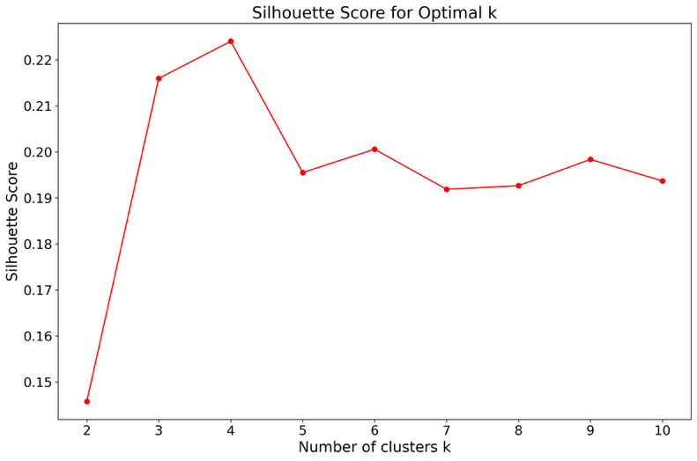
Figure 1: K value across silhouette score
(Source: The author synthesizes)
Figure 1 plots the average silhouette score across candidate numbers of clusters k from 2 to 10. The curve increases strongly at small k and reaches its highest level at k = 4, with a silhouette score of about 0.21, after which the scores decline slightly and fluctuate without improvement. This pattern indicates that four clusters achieve the best balance between within cluster compactness and between cluster separation for our sample. Accordingly, we choose k = 4 for the K Means estimation and use this specification for all subsequent profiling and validation steps.

4. RESEARCH RESULTS AND DISCUSSION

4.1 Descriptive Analysis
Table 2 reports summary statistics for 3,528 firm-year observations. Core firm characteristics are stable relative to other variables: firm size (log assets) averages 11.93 with modest dispersion (sd = 0.66) and near-normal shape (skew = 0.29, kurtosis = 0.09), while age averages 21.91 years but is right-skewed (skew = 1.58). Capital structure is moderate on average: debt-to-assets (LEV) centers near 0.49 with a relatively tight spread (sd = 0.22) and slight left skew, and debt-to-equity averages 1.49 but varies more widely (sd = 1.49). Net working capital scaled by assets is positive on average (mean = 0.24), indicating generally solvent short-term positions across firms.

Table 2: Descriptive Analysis
 | count | mean | std | min | median | max | skew | kurtosis
SIZE | 3528 | 11,93 | 0,66 | 10,22 | 11,9 | 14,16 | 0,29 | 0,09
Age | 3528 | 21,91 | 7,66 | 6 | 20 | 66 | 1,58 | 4,05
ROA | 3528 | 0,35 | 1,27 | -0,47 | 0,04 | 20,05 | 8,89 | 101,07
ROE | 3528 | 0,65 | 2,1 | -2,09 | 0,08 | 29,21 | 6,95 | 60,97
ROS | 3528 | 0,68 | 3,76 | -0,73 | 0,05 | 106,32 | 14,39 | 278,29
LEV | 3528 | 0,49 | 0,22 | 0,03 | 0,51 | 0,92 | -0,22 | -0,89
NWC | 3528 | 0,24 | 0,23 | -0,38 | 0,21 | 0,93 | 0,43 | -0,05
Debt_to_asset | 3528 | 0,49 | 0,22 | 0,03 | 0,51 | 0,92 | -0,22 | -0,9
debt_to_equity | 3528 | 1,49 | 1,49 | 0,04 | 1,03 | 11,17 | 2,21 | 6,74
EPS | 3528 | 1922,42 | 1881,9 | 0,53 | 1417,08 | 14601 | 2,27 | 7,59
Historic_PE | 3528 | 23,47 | 81,27 | 0,35 | 7,72 | 1295,53 | 9,41 | 105,79
M_B | 3528 | 1,04 | 0,91 | 0,07 | 0,77 | 7,8 | 2,92 | 12,14
(Source: The author synthesizes)
Profitability and market-based measures exhibit heavy right tails. ROA, ROE, and ROS have small medians but very large maxima (ROA max = 20.05, ROE max = 29.21, ROS max = 106.32) and extreme skewness and kurtosis, signaling a few exceptional performers or reporting spikes. Market indicators are similarly dispersed: EPS averages 1,922 with a wide range, the historic P/E ratio averages 23.47 yet has a very long right tail (skew = 9.41), and the market-to-book ratio averages 1.04 with pronounced right skew (skew = 2.92). Overall, the distributional features justify standardization and robustness checks in the clustering stage, as a handful of high-value observations can otherwise dominate distance calculations.

4.2 Results
Figure 2 shows the distribution of firms across the four K means clusters selected earlier. Cluster 2 is the largest group with 1,416 firms, accounting for 40.14 percent of the sample, followed by Cluster 1 with 1,159 firms (32.85 percent) and Cluster 0 with 904 firms (25.62 percent). Cluster 3 is a small residual group with 49 firms (1.39 percent). The pattern indicates a moderately unbalanced partition with one dominant cluster and one very small cluster, which is informative for profiling but warrants caution when interpreting statistics for the smallest group.
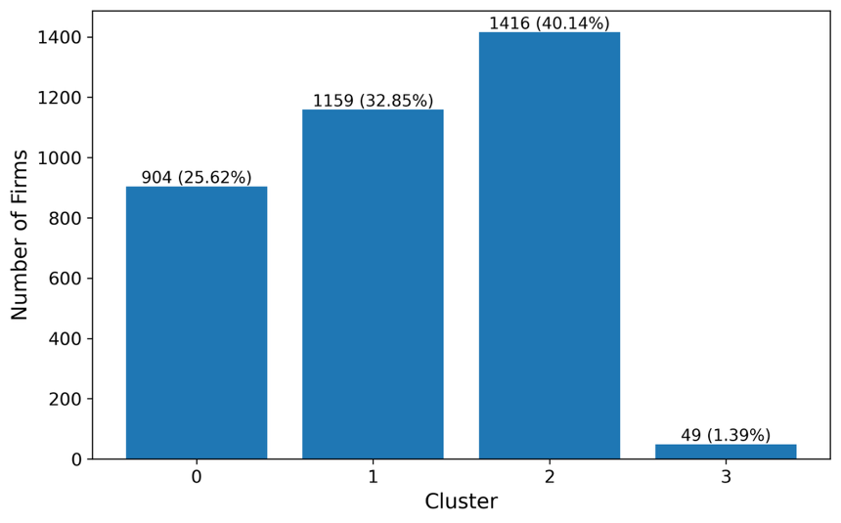
Figure 2: K value across silhouette score
(Source: The author synthesizes)
Table 3 profiles the four clusters in Figure 2 and shows clear differences that matter for credit rating segmentation. The three large clusters are broadly comparable in size and age, but they diverge on leverage, liquidity, ownership, and valuation. Cluster 2, which contains the most firms, exhibits the lowest leverage ratios (debt to assets 0.469; debt to equity 1.35), the highest foreign ownership (11.81 percent), and the highest market to book ratio among the large groups. Profitability is moderate and stable. This configuration points to stronger balance sheet quality and external monitoring, consistent with a more favorable credit profile. Cluster 0 is similar in scale and age but is more levered (debt to assets 0.515; debt to equity 1.70) and slightly more liquid on net working capital, suggesting higher financial risk despite adequate operating performance. Cluster 1 shows the lowest net working capital among the large groups and sits in the middle on leverage, with slightly higher profitability and the lowest historic P E, which may reflect lower growth pricing. From a ratings orientation, Cluster 2 looks strongest, Cluster 0 looks more debt dependent, and Cluster 1 raises liquidity attention.
Table 3: Clusters summary
Cluster | 0 | 1 | 2 | 3
SIZE | 11,96817 | 11,88657 | 11,96961 | 11,17123
Foreign ownership | 8,989782 | 8,955411 | 11,80562 | 3,370263
Age | 21,25996 | 21,08887 | 22,96328 | 22,97959
ROA | 0,213285 | 0,243345 | 0,23096 | 8,554321
ROE | 0,44945 | 0,492529 | 0,452043 | 13,74983
ROS | 0,426255 | 0,394349 | 0,388273 | 20,74252
LEV | 0,514507 | 0,499411 | 0,468971 | 0,353815
NWC | 0,27291 | 0,194548 | 0,251456 | 0,324107
Debt_to_asset | 0,514546 | 0,499422 | 0,469032 | 0,353673
debt_to_equity | 1,701903 | 1,517179 | 1,348912 | 0,795918
Historic_PE | 26,69983 | 20,25936 | 23,15344 | 49,19018
M_B | 1,025638 | 0,997204 | 1,083004 | 0,771065
(Source: The author synthesizes)
Cluster 3 is a very small group and should be interpreted with caution, yet its profile is distinctive for credit analysis. Firms in this group are the smallest by assets and have the lowest foreign ownership, but display unusually high accounting profitability measures together with very low leverage and high historic P E. The combination of extreme returns and thin external ownership can reflect niche business models, temporary windfalls, or measurement idiosyncrasies that ratings analysts would investigate before assigning a view on sustainability. Overall, the clusters separate firms along dimensions that map naturally to credit risk capacity. Low leverage with stronger external ownership and moderate valuations aligns with higher capacity, while higher leverage or weaker liquidity flags potential vulnerabilities even when profitability appears solid.
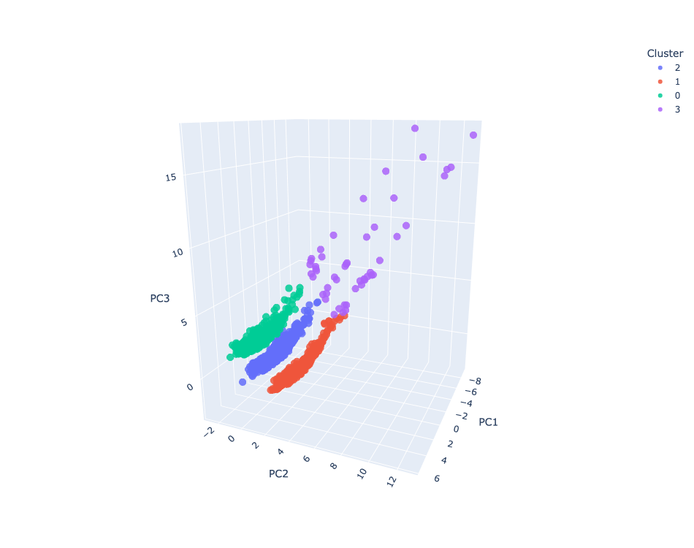
Figure 3: Clusters with 3 PCA
(Source: The author synthesizes)
Figure 3 projects firms onto the first three principal components of the standardized feature set and colors points by the four clusters. The display shows clear stratification that aligns with earlier results: the largest group in Figure 2 (Cluster 2) forms a compact band that is distinct from Clusters 0 and 1, which appear adjacent with modest boundary overlap, consistent with their similar size and age but differing leverage, liquidity, and ownership in Table 3. By contrast, the very small Cluster 3 sits as a sparse cloud positioned away from the bulk of observations, which accords with its unusual combination of very low leverage and extremely high profitability and valuation indicators in Table 3. Overall, the separation in principal component space corroborates the four-cluster solution and supports the economic interpretation of differences documented in Table 3.

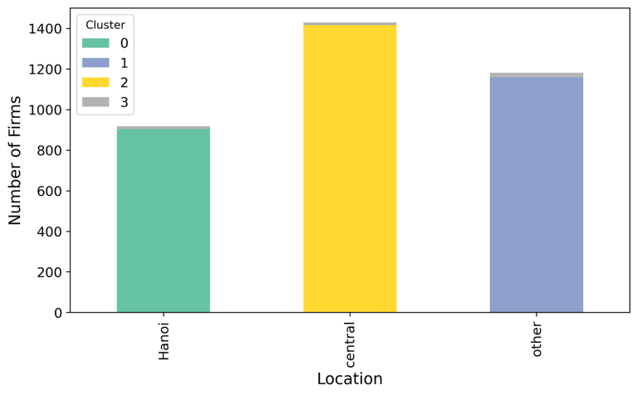
Figure 4: Location by clusters
(Source: The author synthesizes)
Figure 4 cross tabulates cluster membership by location and shows that the central region hosts the largest number of firms and is dominated by Cluster 2, consistent with Figure 2 where Cluster 2 is the largest group and with Table 3 where it exhibits lower leverage and higher foreign ownership. The “other” regions are mostly Cluster 1, while Hanoi has a higher share of Cluster 0; Cluster 3 is a small fringe in every location. This uneven geographic composition reinforces that the clusters capture structural differences that co-move with location, which is informative for a credit rating orientation and suggests that regional controls or robustness checks by location are warranted.
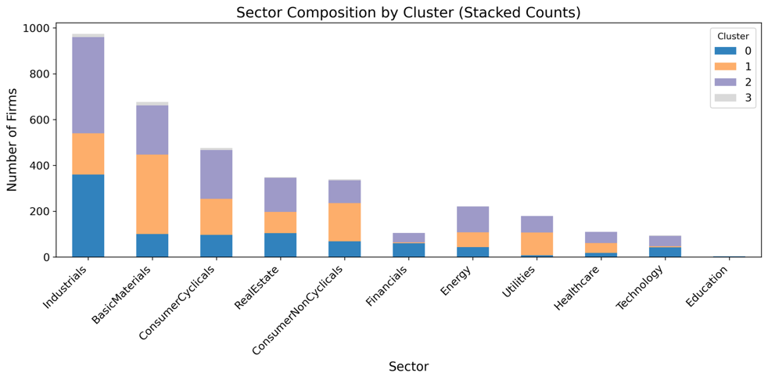
Figure 5: Sectors by clusters
(Source: The author synthesizes)
Figure 5 cross tabulates clusters by sector and shows that Industrials and BasicMaterials contain the largest firm counts, with Cluster 2 dominating most sectors and Cluster 1 typically second, consistent with the overall sizes in Figure 2. Cluster 0 appears more visibly in capital-intensive sectors such as Industrials, BasicMaterials, and Real Estate, which aligns with its higher leverage profile in Table 3, while consumer sectors tilt further toward Cluster 2. Financials, Energy, Utilities, Healthcare, Technology, and Education are smaller in absolute numbers but preserve the same ordering, and Cluster 3 remains marginal everywhere. The pattern indicates that the four-cluster structure is not simply a sector label; instead, sectoral mixes reinforce but do not fully explain the balance-sheet strength, ownership, and valuation differences documented in Table 3.
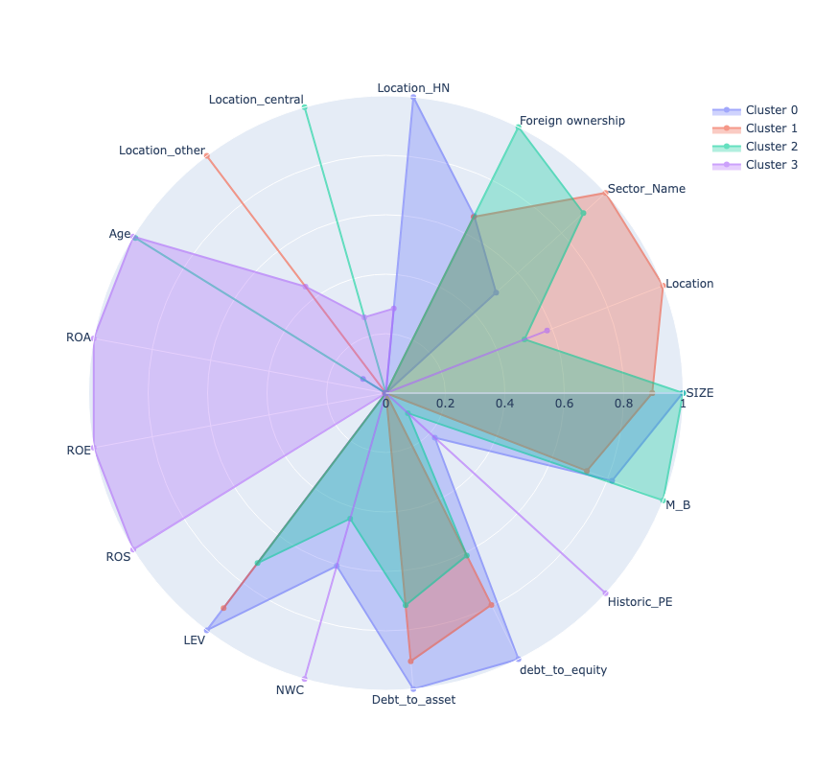
Figure 6: Radar profile by clusters
(Source: The author synthesizes)
Figure 6 synthesizes the multidimensional differences across clusters by plotting normalized means for all variables. The polygon for Cluster 2 expands most on foreign ownership, firm size, and the market to book ratio, while it contracts on leverage, debt to assets, and debt to equity. This configuration matches a lower risk balance sheet with stronger external monitoring and moderate profitability. Cluster 0 shows the opposite pattern, with higher leverage and debt ratios and comparatively weaker valuation metrics, alongside only moderate net working capital. Cluster 1 is distinguished by the lowest net working capital and middle-of-the-pack leverage with relatively muted valuation indicators, suggesting tighter short-term liquidity despite acceptable operating results. Cluster 3 stands out with very high return on assets, return on equity, and return on sales, very low leverage, and small size and foreign ownership, a profile that can reflect niche models or transient windfalls that merit careful validation.
These radar shapes align with earlier evidence and help explain the counts in Figure 2 and the averages in Table 3. The dominance of Cluster 2 in the sample and in several locations and sectors (Figures 4 and 5) is consistent with its strong balance sheet and higher external ownership. The heavier presence of Cluster 0 in capital-intensive sectors mirrors its higher leverage, while the concentration of Cluster 1 in other regions fits its liquidity sensitivity. Given a credit rating orientation, Cluster 2 exhibits the strongest capacity, Cluster 0 signals elevated financial risk, Cluster 1 warrants attention to working capital management, and Cluster 3 should be interpreted with caution due to its small size and unusually high profitability. Overall, the radar confirms that the four clusters are economically coherent and not driven by a single variable or sector.

5. CONCLUSION AND POLICY IMPLICATIONS

5.1 Conclusion
This study set out to discover economically interpretable clusters of Vietnamese listed firms during 2019–2024 using a theory-informed feature set and K-means, read in a credit-rating orientation. The results support a four-cluster solution: a dominant group with lower leverage, higher foreign ownership, and stronger valuation signals; a more debt-dependent group; a liquidity-sensitive group with low net working capital; and a small residual group with unusually high profitability and very low leverage. Taken together, the segmentation reveals persistent cross-sectional structure in fundamentals, ownership, and geography that is consistent with the study’s objective of producing a transparent, data-driven grouping for risk screening.
The evidence aligns with and extends prior work on Vietnam’s market. Local asset-pricing studies show that factor payoffs and sentiment differ from developed markets, and that characteristic information beyond market beta matters for performance, which is consistent with the prominence of valuation and profitability in the largest cluster (Huang et al., 2023; Phong & Hoang, 2012; Thanh et al., 2024). Liquidity and ownership have also been linked to return dynamics in Vietnam, especially around stress episodes, which resonates with the observed differences in turnover-proxied environments and foreign ownership across clusters (Luong et al., 2022; Nguyen et al., 2021; Tran et al., 2018). By summarizing these influences through unsupervised learning, the study provides a market-wide view that complements earlier model-specific tests.
The cluster profiles are also coherent with foundational theories that guided feature design. Differences in leverage and liquidity map to trade-off and pecking-order logic, as well as agency considerations about monitoring and free cash flow, while higher foreign ownership in stronger clusters is consistent with governance channels that reduce frictions (Jensen & Meckling, 2019; Kraus & Litzenberger, 1973; Modigliani & Miller, 1963; Myers & Majluf, 1984). Valuation and profitability contrasts connect to asset-pricing and arbitrage perspectives that emphasize characteristic-based premia and to momentum effects that capture underreaction, justifying the inclusion of these variables in the clustering space (Fama & French, 2015; Ross, 2013; Sharpe, 1964). Finally, the separation along balance-sheet strength and earnings quality echoes structural and reduced-form views of credit risk, and it reflects ratios long used in failure prediction (Jarrow & Turnbull, 1995; Merton, 1974).
The study contributes in three ways. First, it operationalizes well-known finance and risk theories into a coherent, reproducible feature set for unsupervised learning in an emerging market, anchoring variables in mechanisms rather than ad hoc choices. Second, it delivers an interpretable four-cluster partition of HOSE and HNX firms that is externally coherent across sectors and regions, offering a practical screening layer for credit-rating contexts and complementing recent Vietnamese work that applies clustering or neural networks to rating problems. Third, it aligns with international evidence that machine-learning methods can reveal nonlinear interactions relevant for distress and credit capacity, thereby bridging local empirical findings with global advances in predictive modeling (Alanis et al., 2022; Barboza et al., 2017; Zięba et al., 2016).
Overall, the analysis shows that a theory-guided K-means approach can uncover meaningful firm groupings in Vietnam’s listed universe. The four clusters are statistically and economically distinct and align with established mechanisms in asset pricing, corporate finance, and credit risk, while remaining consistent with the contours of the local empirical literature. This supports the use of the segmentation as a transparent foundation for downstream risk assessment, monitoring, and comparative analysis in the Vietnamese context.

5.2 Limitations & Further research
The segmentation relies on firm level information from 2019 to 2024 and therefore may not capture longer cycle dynamics, structural breaks, or policy regime shifts outside this window. The use of Z score filters to remove extreme observations improves robustness but can also trim genuine tail events that matter for credit risk. K means with Euclidean distance emphasizes spherical clusters and equal variable weighting after standardization, which may underrepresent nonlinear boundaries or differing materiality of variables. Finally, while location and sector are examined descriptively, the model itself is not explicitly causal and does not incorporate macroeconomic state variables or market wide liquidity shocks during estimation.
Future work can extend the framework in three directions. First, introduce time dynamics by clustering on rolling windows or by estimating hidden Markov structures so that firms can transition across segments as their fundamentals evolve. Second, compare alternative distance metrics and clustering engines, such as Gaussian mixture models, spectral clustering, or density-based methods, and incorporate macroeconomic indicators and market liquidity states to test stability across regimes. Third, link the unsupervised labels to supervised tasks by training transparent predictive models for downgrade and default that use the cluster label and its proximity to boundaries as features, and deploy explainability tools to attribute risk changes to specific financial drivers in a way that is auditable for policy and governance.

FUNDING
The research is funded by the University of Economics and Law, Vietnam National University, Ho Chi Minh City, Vietnam.

REFERENCES
Akerlof, G. A. (1978). The market for “lemons”: Quality uncertainty and the market mechanism. In Uncertainty in economics (pp. 235-251). Elsevier.
Alanis, E., Chava, S., & Shah, A. (2022). Benchmarking machine learning models to predict corporate bankruptcy. arXiv preprint arXiv:2212.12051.
Altman, E. I. (1968). Financial ratios, discriminant analysis and the prediction of corporate bankruptcy. The journal of Finance, 23(4), 589-609.
Amihud, Y. (2002). Illiquidity and stock returns: cross-section and time-series effects. Journal of financial markets, 5(1), 31-56.
Anh, N. H., Duong, D. T., Yang, T., & Yoon, S. W. (2017). An Investigation of Credit Rating and Capital Structure: Empirical Evidence from Listed Companies on Vietnam Stock Market. Pan-Pacific Journal of Business Research, 8(1), 47-54.
Barboza, F., Kimura, H., & Altman, E. (2017). Machine learning models and bankruptcy prediction. Expert systems with applications, 83, 405-417.
Barney, J. (1991). Firm resources and sustained competitive advantage. Journal of management, 17(1), 99-120.
Fama, E. F. (1970). Efficient capital markets: A review of theory and empirical work. The journal of Finance, 25(2), 383-417.
Fama, E. F., & French, K. R. (1993). Common risk factors in the returns on stocks and bonds. Journal of financial economics, 33(1), 3-56.
Fama, E. F., & French, K. R. (2015). A five-factor asset pricing model. Journal of financial economics, 116(1), 1-22.
Huang, X., Liu, C., & Shu, T. (2023). Factors and anomalies in the Vietnamese stock market. Pacific-Basin Finance Journal, 82, 102176.
Jarrow, R. A., & Turnbull, S. M. (1995). Pricing derivatives on financial securities subject to credit risk. The journal of Finance, 50(1), 53-85.
Jegadeesh, N., & Titman, S. (1993). Returns to buying winners and selling losers: Implications for stock market efficiency. The journal of Finance, 48(1), 65-91.
Jensen, M. C. (1986). Agency costs of free cash flow, corporate finance, and takeovers. The American economic review, 76(2), 323-329.
Jensen, M. C., & Meckling, W. H. (2019). Theory of the firm: Managerial behavior, agency costs and ownership structure. In Corporate governance (pp. 77-132). Gower.
Kraus, A., & Litzenberger, R. H. (1973). A state-preference model of optimal financial leverage. The journal of Finance, 28(4), 911-922.
Luong, T. A., Nguyen, T. H., Nguyen, T. T., Dau, T. V., Le Ha, V., & Le Thi, P. U. (2022). The impact of market liquidity on stock returns: Empirical evidence from the Vietnamese stock market. VNU Journal of Economics and Business, 2(5), 93-102.
Luu, T.-M.-N., Nguyen, P. M., & Ta, H. H. (2024). Revisiting the Corporate Governance–Firm Performance Nexus in Vietnam: Does Capital Structure Really Matter? Indian Journal of Corporate Governance, 17(2), 182-201.
Merton, R. C. (1974). On the pricing of corporate debt: The risk structure of interest rates. The journal of Finance, 29(2), 449-470.
Modigliani, F., & Miller, M. H. (1963). Corporate income taxes and the cost of capital: a correction. The American economic review, 53(3), 433-443.
Myers, S. C. (1984). Capital structure puzzle. In: National Bureau of Economic Research Cambridge, Mass., USA.
Myers, S. C., & Majluf, N. S. (1984). Corporate financing and investment decisions when firms have information that investors do not have. Journal of financial economics, 13(2), 187-221.
Nguyen, C. T., Hai, P. T., & Nguyen, H. K. (2021). Stock market returns and liquidity during the COVID-19 outbreak: evidence from the financial services sector in Vietnam. Asian journal of Economics and Banking, 5(3), 324-342.
Nguyen, P. D. (2024). The impact of intellectual capital on firm performance: A study of Vietnamese firms listed on Vietnam Stock Exchange. Journal of Competitiveness, 16(1).
Pham, Q. H., Ho, D., & Khandaker, S. (2022). Credit Rating Models for Firms in Vietnam Using Artificial Neural Networks (ANN). International Econometric Conference of Vietnam,
Phong, N. A., & Hoang, T. V. (2012). Applying Fama and French three factors model and capital asset pricing model in the stock exchange of Vietnam. International Research Journal of Finance and Economics, 95(8), 114-120.
Ross, S. A. (1977). The determination of financial structure: the incentive-signalling approach. The bell journal of economics, 23-40.
Ross, S. A. (2013). The arbitrage theory of capital asset pricing. In Handbook of the fundamentals of financial decision making: Part I (pp. 11-30). World Scientific.
Sharpe, W. F. (1964). Capital asset prices: A theory of market equilibrium under conditions of risk. The journal of Finance, 19(3), 425-442.
Tam, P. H., & Quang, T. C. (2024). Credit rating by clustering algorithm in the Vietnam Stock Exchange market. VNUHCM Journal of Economics-Law and Management, 8(3), 5494-5512.
Thanh, C. N., Huy, T. P., & Nhat, A. N. (2024). Investor sentiments and Fama-French five-factor in Vietnam market. International Journal of Revenue Management, 14(2), 203-220.
Tran, L. T. H., Hoang, T. T. P., & Tran, H. X. (2018). Stock liquidity and ownership structure during and after the 2008 Global Financial Crisis: Empirical evidence from an emerging market. Emerging Markets Review, 37, 114-133.
Tran, N. P., Dinh, C. T. H., Hoang, H. T. T., & Vo, D. H. (2022). Intellectual capital and firm performance in Vietnam: The moderating role of corporate social responsibility. Sustainability, 14(19), 12763.
Zięba, M., Tomczak, S. K., & Tomczak, J. M. (2016). Ensemble boosted trees with synthetic features generation in application to bankruptcy prediction. Expert systems with applications, 58, 93-101.

